title of the paper (SEGOE UI SEMIBOLD, UPPER CASE, 12 PT, LEFT, SPACING BEFORE: 22 PT)
Author’s Name¹*, Author’s Name² (Segoe UI Semilight, 9 pt, italic, left, spacing before and after: 9 pt)
¹University/Institute, School/College/Faculty, Department/Division, City, Country; e-mail: xxxx@xxx
²University/Institute, School/College/Faculty, Department/Division, City, Country; e-mail: xxxx@xxx (Segoe UI Semilight, 8 pt, regular, left)
Abstract: The abstract should be placed here and should be between 300 and 350 words long (Segoe UI Semilight, 8 pt, regular, left, spacing before: 9 pt).
Keywords: up to 5 terms separate with semicolons (Segoe UI Semilight, 8 pt, regular, left, spacing before: 9 pt).

1. Introduction (Segoe UI Sembold, 10 pt, regular, left, spacing before: 12 pt, spacing before: 2 pt)
Paper size is set to 170 × 240 mm, top and bottom margin 15 mm; left and right margins 22 mm. For the main text, use Segoe UI Semilight, 9 pt font size, single line spacing and justified paragraph.
The opening paragraph in every section or subsection should not be indented, while all the other paragraphs in the section or subsection should be intended for 5 mm.

2. Section title

2.1. Subsection title (Segoe UI Semilight, 10 pt, italic, left, spacing before: 12 pt, spacing before: 2 pt)
If you wish to divide a section into several smaller subsections then make sure you have at least two subsections within it. Also, one paragraph must have at least two sentences.

2.1.1. Sub subsection title
If you wish to divide a subsection into several smaller sub subsections then make sure you have at least two sub subsections within it. Main text regarding figures (Figure 1) and tables (Table 1). For literature reference use APA style (See Instruction for authors).
Lists in text should be in following format:
- Text Level 1
- Text Level 2
- Text Level 2
- Text Level 1
- Text Level 2
- Text Level 2
- Text Level 2

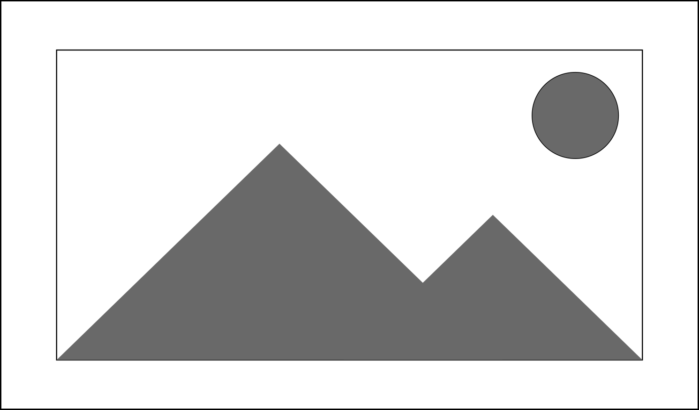
Figure 1. Title of the figure, photo, map, image
Note. Adapted from "Title of Article," by A. A. Author and B. B. Author, year, Title of Periodical, Volume(Issue), p. xx (DOI or URL). CC BY-NC. (Segoe UI Semilight, 8 pt, regular, left, spacing before: 6 pt, spacing before: 9 pt).
Table 1. Description of contents
Column description | Column description | Column description | Column description
Row | x | x | x
Row | x | x | x
Row | x | x | x
Note. The participants’ responses; *p < .05
Table 2. Description of contents
Column description | Column description | Column description | Column description | Column description | Column description | Column description
Row | x | x | x | x | x | x
Row | x | x | x | x | x | x
Row | x | x | x | x | x | x
Note. The participants’ responses. From "Title of Article," by A. A. Author and B. B. Author, year, Title of Periodical, Volume(Issue), p. xx (DOI or URL). CC BY-NC
For the table content, please use style: Segoe UI Semilight, 8 pt, regular, center align; while for the first column content, use left align.
Equations: Equations of the type a + b = c can be written as normal text. For all other equations, please use Microsoft equation editor, and insert the graphic into your text file as an object. For equations formatting use Segoe UI Semilight, 9 pt, regular, center align.

 | $$\text{IBP} \text{=} \frac{{\text{V}}_{\text{b}}}{{\text{V}}_{\text{u}}}\text{∂}\text{ – }\text{Xy}$$ | (1)
Acknowledgements (Segoe UI Semibold, 9 pt, left, spacing before 12 pt and after 2 pt)
Acknowledgements should be placed here (Segoe UI Semibold, 9 pt, left, spacing before and after 0 pt).
References (Segoe UI Semibold, 9 pt, left, spacing before 12 pt and after 2 pt)
Author, A. A., Author, B. B., & Author, C. C. (Year of publication). Title of article. Title of Journal, Volume number(Issue number), pages range of the article: xx–xx. https://doi.org/xxx or https://xxx
Author, A. A. (Year of publication). Title of Book: Capital Letter Also for Subtitle. Publisher.
Author, A. A. (Year of publication). The title of the book in the original language [Title of the book in English]. Publisher.
Author, A. A., & Author, B. B. (Year of publication). Title of chapter. In A. Editor & B. Editor (Eds.), Title of Book (pages of chapter: pp. xx–xx). Publisher. https://doi.org/xxx or https://xxx
Author, A. A., & Author, B. B. (Year of publication). Title of document. https://doi.org/xxx or https://xxx
Author, A. A., Author, B. B., & Author, C. C. (Year of publication, Month day–day), Title of contribution [Type of contribution], Conference Name, Location, https://doi.org/xxx or https://xxx
Author, A. A. (Year of publication). Title of dissertation [Unpublished doctoral dissertation]. Name of Institution Awarding the Degree.
Author, A. A. Title of data set (Version x. x) [Data set]. Publisher Name. https://doi.org/xxx or https://xxx
Author, A. A. (Year of publication, Month day). Title of work. Site Name. https://xxx or Retrieved Month day, year, from https://xxx (when the content of the page is susceptible to change over time and the page is not archived)
(Segoe UI Semibold, 8 pt, left, spacing before and after 0 pt, hanging by 5 mm)
*****FOR MORE DETAILS, PLEASE VISIT AUTHOR GUIDELINES’ PAGE AT****
https://ojs.gi.sanu.ac.rs/index.php/zbornik/Authors_Guidelines

*Corresponding author, e-mail: xxxx@xxx

